

# **SUMMER EXAMINATIONS 2015**

**Wednesday, 13th May 2015, 14.30 p.m. – 16.30 p.m.**

**KSDEM_8_Y2**

**Courses:** Bachelor of Science (Hons) in Software Development

**Year:** Two

### Subject: Software Development

### Time Allowed: 2 Hours

**Instructions: 1.** Attempt **any THREE (3)** of the following **FIVE (5)**

questions**.**

1. Questions do not carry equal marks
2. Start each question on a new page.
3. Write the question number at the top of each page.
4. Circle the numbers of the questions you answer at the front of your answer book.

**Additional Attachments or Exam Material to accompany this paper:**

### None

**Internal Examiner(s): External Examiner(s):**

Mr. Brendan Watson Mr Brian Gillespie

**Question 1**

Read the following information and answer the questions below:

In a leisure center, employees oversee members checking in and out. Members may have training plans prepared for them by employees. Each training plan specifies a number of sessions. A member may book sessions on the gym equipment and they can also enroll for fitness classes.

The details stored on employees are name, id number and the details stored on members are name, membership number, start date and end date. The details stored on training plans are plan duration and plan description. The details stored on sessions are start date and time, duration and intensity and the details stored on gym equipment are description and number of machines. The details stored on fitness classes are description, start date and time.

1. Draw the UML class diagram which models the information given above and specify name and multiplicity of each association and specify suitable types for all the attributes. Explain what the role of an association means and add roles to each end of any three of the associations in your class diagram. **(14 marks)**

1. On your UML class diagram specify the following using UML:

* All the name attributes contains between one and three strings.
* Add an attribute called medicalConditions to the Member class and specify that it can hold many medical conditions and once a medical condition is added, it cannot be changed or deleted.

**(4 marks)**

1. Explain class scope. Add a suitable class scoped attribute to any of the classes in your class diagram and outline why you think the attribute you added should be class scoped.

**(8 marks)**

1. Draw an instance diagram using the information below and your UML class diagram. Make up any other sample data you need for attribute values.

Mary Kelly a member of Moylish Leisure Center had a cardio training plan prepared by Tony Harney and as a result she booked three one hour high intensity sessions on a rowing machine and 2 one hour low intensity sessions on a cross-trainer.

**(8 marks)**

**(Total 34 Marks)**

**Question 2**

1. In relation to use case modelling explain what a communication relationship models. Explain uni-directional and bi-directional communication relationships and develop a use case diagram showing an example of each and explain your use case diagram.  **(8 marks)**
2. Develop a use case diagram showing a use case called Display ATM Menu. On your diagram specify that the Display ATM Menu use case includes the following three use cases: Validate PIN & User, Get Cash from ATM, View Account Balance. Identify one exceptional case which could occur in Validate Pin and identify two exceptional cases which could occur in Get Cash from ATM and update your use case diagram to show the three exceptional cases. Show a suitable actor and show the system boundary on your diagram.

**(9 marks)**

1. Using the use case diagram you developed for Question 2 part b) above, document the following use cases: Display ATM Menu, Validate PIN & User, Get Cash from ATM, View Account Balance. Also document any two of the exceptional use cases you identified. Document the use cases using the following headings: Use Case name, Participating Actor, Entry Conditions, Flow of Events, Exit conditions.

**(16 marks)**

**(Total 33 Marks)**

**Question 3**

1. Give a definition of inheritance and explain three points about inheritance **(10 marks)**
2. Sketch Figure 1 in your answer book and do the following:
3. Label the root class and all of the subclasses and leaf classes.

**(3 marks)**

1. Add a class called MonsterPieEater which has an attribute called size of type integer. Objects of this class can move on the grid and eat Pies but in addition MonsterPieEaters can eat PieEaters.

**(4 marks)**

1. Add a suitable bi-directional associations so that PieEaters may eat Pies and MonsterPieEater may eat PieEaters.

**(4 marks)**

1. Suppose there is a requirement to add a class called PoisonPlant with an attribute called poisonType of type string. Objects of this class can’t move on the grid but can eat any PieEater objects which walk on them. Describe any problems you encounter when you try to add a PoisonPlant class to the diagram. Show how you overcame the problems by adding the PoisonPlant class to your diagram.

**(6 marks)**

1. List all the features of the MonsterPieEater class. What objects can a MonsterPieEater object be linked to? Explain your answer.

**(6 marks)**

**(Total 33 Marks)**

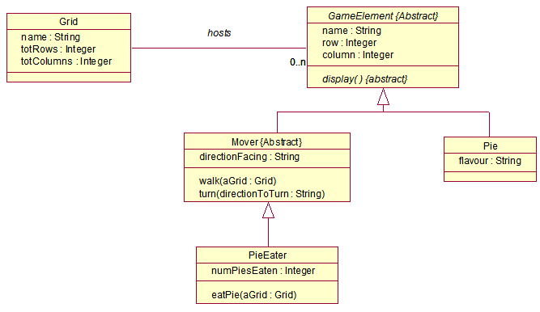

**Figure 1**

**Question 4**

1. Explain functional and structural testing. Explain how functional and structural testing apply to unit testing.

**(6 marks)**

1. Develop a control flowgraph for the pseudo code sample below and determine the complexity. How many paths would you need to test to guarantee complete coverage? Suppose the method below has been tested so that TER0 = 0.7 and TER1 = 0.6, would you recommend further testing? Explain your answer.

**(12 marks)**

1. Develop a branch and block table for the Pseudo code sample below.

**(15 marks)**

**(Total 33 Marks)**

**//** Below Psuedo code searchFirstRowEatingPies method**.**

searchFirstRowEatingPies (aGrid : Grid): integer //Line Reference Nos.

{ // 1

initialise( ) // 2

walk (aGrid) // 3

4 timesRepeat // 4

{ // 5

turn (left) // 6

} // 7

If aGrid pieInSight (this) = true // 8

{ // 9

eatPie (aGrid) // 10

} // 11

initialise( ) // 12

aGrid getTotColumns( ) timesRepeat // 13

{ // 14

If aGrid pieInSight (this) = true // 15

{ // 16

eatPie (aGrid) // 17

} // 18

Else // 19

{ // 20

walk (aGrid) // 21

} // 22

} // 23

return getPiecount( ) // 24

**Pseudo Code Sample**

**Question 5**

1. Explain the waterfall lifecycle model and draw a diagram of it. Describe four disadvantages of the waterfall lifecycle model.

**(12 marks)**

1. Software development is now seen as team problem solving. Explain each of the four problem solving phases. Are the phases marked by completion of all activities for that phase? Explain your answer.

**(12 marks)**

1. CASE plays an important role in modern software engineering. What is CASE? Explain four benefits of CASE. **(9 marks)**

**(Total 33 Marks)**